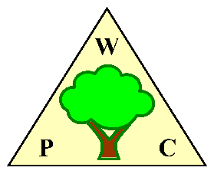

Woodplumpton Parish Council

Catforth Traffic Calming

Project Requirements Specification

Contents

- Speed Limits
- Extent of the Scheme
- Physical Measures
- Additional Measures for inclusion
- Additional Measures for Evaluation
- Measures to improve the safety of School Lane

- Speed Limits

The following speed limits are recommended for the village of Catforth and surrounding roads.

Road | Start and Finish Points | Speed Limit
Lea Lane/Rosemary Lane | Start - Bartle Hall (current 30mph Sign)  Finish - A Point around 200 metres South of the Priory Hospital | 40 Mph
Rosemary Lane/Catforth Road | Start - A Point around 200 metres South of the Priory Hospital  Finish – The junction between Catforth Road and Jane Lane | 30 Mph
Catforth Road | Start – The junction between Catforth Road and Jane Lane  Finish – The junction between Catforth Road and Preston Road | 40 Mph
Lewth Lane/ Preston Road | Start – The junction between Catforth Road and Preston Road Finish – The Junction between Lewth Lane and School Lane | 40 Mph
School Lane | Start – The junction between Catforth Road and School Lane  Finish – The Bridge on School Lane over Woodplumpton Brook | 30 Mph
School Lane | Start – The Bridge on School Lane over Woodplumpton Brook  Finish – The junction between School Lane and Lewth Lane | 40 Mph

Map of Catforth Showing Proposed Speed Limits
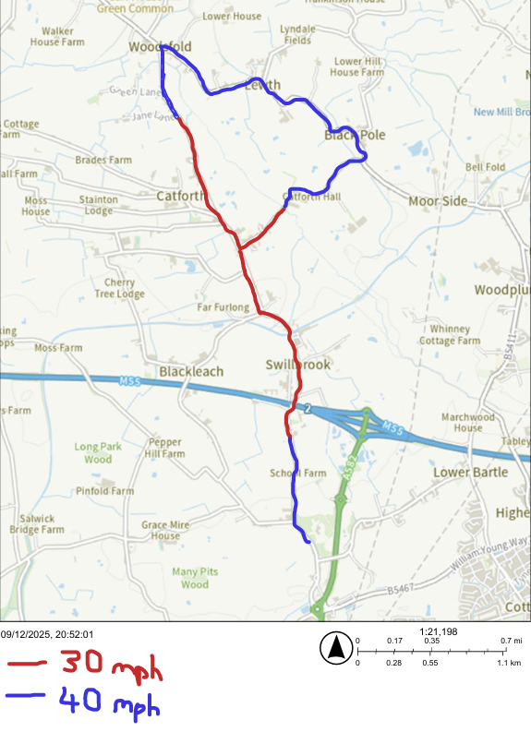

- Extent of the Scheme
It is proposed to mark the extent of the scheme for Catforth with a Gateway at each entrance to the scheme.
The Gateway will consist of signage indicating 30 mph and encouragement to drive carefully, plus road marking to make the gateway obvious. The southern gateway will be within the 30 mph zone, the start of the 30mph zone being marked by a chicane as set out in section 3.
Gateways on a Map
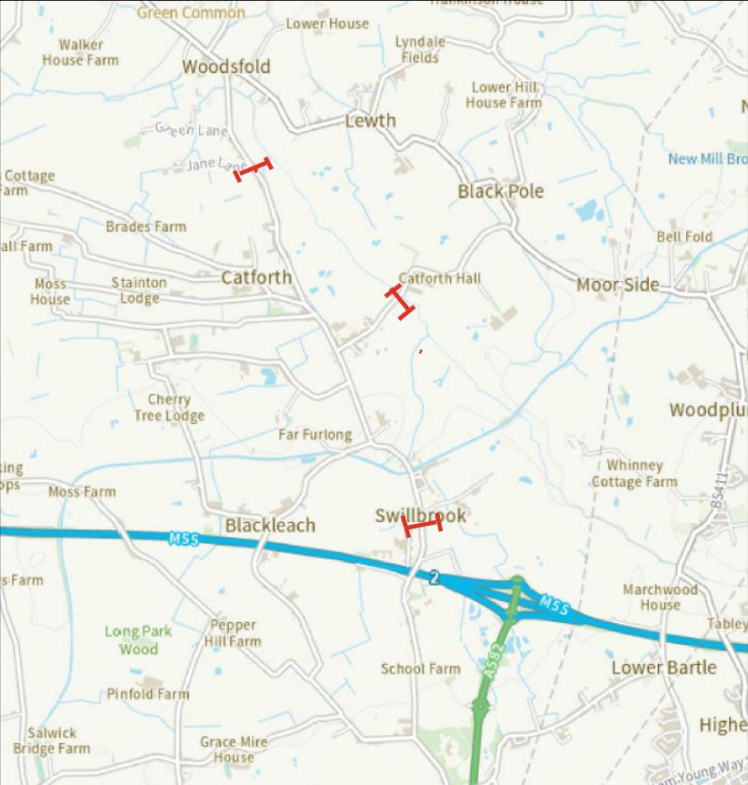

- Physical Measures
Chicanes are to be constructed in the following locations:
- South of Jane Lane – in the same position as envisaged in the previous Scheme
- North of Blackleach Lane – in the same position as envisaged in the previous Scheme.
- At the start of the 30mph zone on the approach to the Priory Hospital from the South.

Each chicane will be a parallel narrowing of the road to a single carriageway with fixed priority. These will slow the traffic, while providing minimal inconvenience to agricultural traffic.

A bus cushion is to be installed covering the entire junction between Catforth Road and School Lane

Location of the Physical Measures on a Map
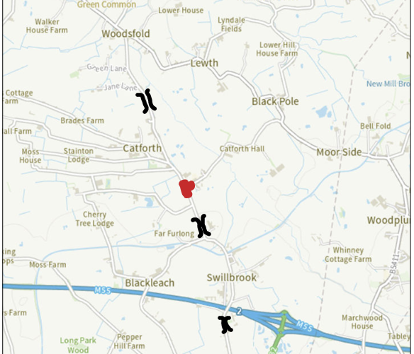

- Additional Measures to Reduce Traffic Speed

The following additional measures to reduce traffic speed will be included in the scheme.

- Speed limit repeater signs
- Speed Limit Roundals on the Road Surface
- Solar powered Speed Indicator Devices
- Appropriate Hamilton Baillie psychological measures

- Additional Measures for Consideration

The following additional measures should be evaluated to determine whether they are practical. If the measures are practical then an approximate cost should be provided to the Parish Council, so that they can determine whether the inclusion of the measures provides value for money.

- Traffic lights controlling the flow of traffic over the Jolly Roger bridge (Catforth Road over the Lancaster Canal). The proposal is for a similar arrangement to that where Lea Road crosses the Lancaster Canal.
- A 7.5t (Except for Access) weight limit on Catforth Road – this would reduce the flow of heavy traffic on the road.
- Extending the 20mph advisory limit from School lane to cover also a length of Catforth Road around the junction with School Lane.
- Widening of the footpaths on Catforth Road and School Lane. It is possible that this can be achieved simply by cutting back the hedges at the back of the footpaths.
- Pedestrian crossings on Catforth Road and School Lane, around the junction between Catforth Road and School Lane.

- Measures to Improve safety on School Lane

Some measures will be included to improve the safety on School Lane, particularly at school drop off and collection times as follows.

- Parking restrictions (double yellow lines) around the junction between School Lane and Catforth Road.
- Parking Restrictions (double yellow Lines) around the sharp bend on School Lane near to the bridge over the Woodplumpton Brook.
- Parking Restrictions (White Lines) to prevent parking across residents driveways,
- Improvements to the laybys on School Lane and Catforth Road, in line with the previous scheme. Signage to be placed on the laybys indication No Overnight Parking.
- Improvements to the footpaths on School Lane in line with the previous scheme
- The installation of an in/out gate on the village hall car park, so that vehicles have room to enter and exit at the same time. This makes the car park more usable at busy times.

