Report on the Catforth Traffic Calming Development Consultation.

Introduction
The development consultation was conducted via a total of 7 meetings related to speed and traffic calming in Catforth and 2 further meetings with school leaders and parents to discuss the specific arrangements around the school.
64 people attended the 7 sessions related to speed and traffic calming. 8 people attended the 2 sessions related to arrangements around the school.
Each session involved the opportunity for residents to provide their ideas as well as sharing their views on a number of potential options through voting. Voting was carried out via a show of hands in response to verbal questions. This methodology is a good way of measuring general sentiment, but cannot be used to claim a particular opinion when results are close.
It is impossible to document everything said in these consultations but below is a snapshot of the polls we took and also some of the comments we heard that accompanied them.

Speed Limits.
Before discussing the traffic calming in the village, we started by asking residents about the speed limits around the village.
The results of the polls we conducted are as follows:
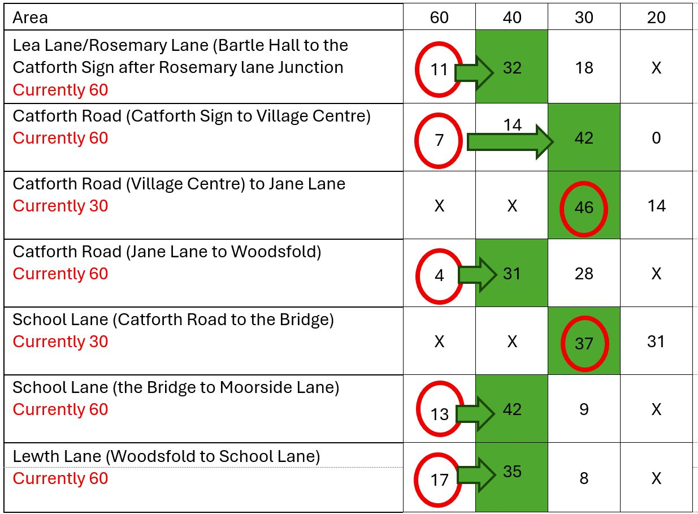
*Red circle indicates current speed, Green box indicates majority opinion.
The polls show you where there was reasonable consensus and where opinion was divided. As well as the limits in those areas the following was also discussed:
- At the south end of the village, the survey team chose the existing “Welcome to Catforth” sign (in the vicinity of Crown Lane Methodist Church) as a suitable demarcation point, where villagers may wish the speed limit to change. The poll was conducted accordingly. Many people discussed whether this speed limit change shouldn’t be further south to protect workers catching buses at Priory Hospital.
- Some residents were concerned with speed limits “chopping and changing” too much.
- Some suggested perhaps a 20mph reduction around the village hall to protect school children.
- When asked about the speed limit through Catforth, some residents felt that the stretch from Benson Lane to Jane Lane may be too long for a 20mph limit, with the stretch from Benson Lane to Square Lane considered more appropriate.
- Speed limit needs to be appropriate for the road conditions to avoid drivers getting frustrated and causing different problems
- Some residents thought the area around the Running Pump should have been considered separately

Traffic Calming Measures

Chicanes
In our previous consultation on traffic calming measures, raised platforms were the most objected to item, however, chicanes were not mentioned as much. We wished to get an idea on people’s views of chicanes. On the whole opinion was divided on chicanes.
33 people said they would be in favour of chicanes with 28 against. If chicanes had to be used residents overwhelmingly preferred the chicanes that are a parallel narrowing of the road. The general feeling was that this would help tractors and other rural traffic negotiate them.
If chicanes were to be used 24 said they would like only 2 chicanes, one at each end of the village with 21 preferring a 3-chicane approach providing an additional one in the middle of the village.

Raised Platforms
It was well understood throughout the meetings that raised platforms were the most controversial point from the last consultation but a suggestion was made that a smaller number could be used. We therefore discussed a number of scenarios around having a smaller number of raised platforms.
Poll:
Suggestion | In Favour | Against
The general principle of including a small number of raised platforms in the scheme | 32 | 28
2 Raised Platforms on School Lane, 1 either side of the school | 19 | 36
Avoidable speed bumps like Cottam Way on used on Catforth Road | 15 | 40
*Yellow indicates majority opinion

The use of raised platforms was also divided. Whilst there was a small majority for a number of raised platforms within the scheme, this seems at odds with the lack of support for 2 raised platforms on School Lane, one either side of the school. It’s worth noting parents at the school were least in favour of this measure, which seemed to be linked to some views that speeding wasn’t the problem at school drop off and pick up times.
This outcome can be explained by the location of the raised platforms. Whilst some wanted raised platforms there was no consensus on where these should go and there were a number of suggestions:
- Platforms around the school
- Platforms around the village hall
- Platforms along the whole road, just fewer
- A single large platform covering the Catforth Road/School Lane Junction

Signage and Road Markings
The vast majority of residents at all consultations were in favour of more signage, repeater signs and Speed Indicator Devices. There was also strong support for the 20mph “flashing” school advisory area covering both Catforth Road around the junction and School Lane (assuming Catforth Road and School Lane remained 30mph speed limit).
Suggestion | In Favour | Against
Speed Limit Signage and Repeater Signs | 55 | 2
SPIDS | 59 | 1
20mph School Advisory on Catforth Road with flashing lights in the vicinity of the School Lane junction. | 46 | 3
Painted markings on the Roadway as part of a psychological scheme to slow the speed of traffic | 31 | 24
*Yellow indicates majority opinion

A small majority were in favour of “Hamilton Baillie” psychological style measures that use road markings and other measures to reduce speed. This generally received a mixed reaction, possibly more due to a perceived lack of effect than outright objection.
Some of the comments we received around signage and road markings included:
- Many residents suggested rumble strips
- 1 resident suggested a number plate recognition Speed Indicator Device
- Residents were happy with painted roundels on the road reminding drivers of speed limits
- There was concern about drivers becoming “sign blind”
- Animals, horses, school, etc signage was all considered
- Speed Indicator Devices would act as a reminder for drivers

Jolly Roger Bridge
Although not originally considered by counsellors, the Jolly Roger bridge was mentioned at nearly every consultation. It was suggested at the third meeting that traffic lights should be installed.
Suggestion | In Favour | Against
Traffic Lights on the Jolly Roger Bridge | 26 | 18
*Yellow indicates majority opinion

Residents commented:
- Jolly roger bridge is a real hazard
- Not wide enough at either side of the bridge
- Concealed entrance sign might be good
- Didn’t believe traffic lights would be feasible due to the give way needing to be too far back
- Light from neighbouring property causes drivers to think there is an oncoming vehicle
- Causes frustration and angry driving

School Lane Parking
Residents were overwhelmingly of the belief that there should be no blanket parking restriction around the school.
Parking as is | 2
Prohibit Parking on School Lane | 1
Some parking restrictions, allowing some parking | 62
*Yellow indicates majority opinion

Whilst a blanket ban on parking wasn’t supported, it was the strong belief of all the residents that bad parking occurred regularly around the junction with Catforth Road and on the bend down school lane and that this should be discouraged with the use of double yellow lines.

Other Considerations

School Lane
A number of issues were raised around school lane predominantly from parents but from residents too:
- Parking slows the cars and removing it would only make the situation worse and push parents to cross roads they don’t need to.
- Parents regularly stand in the road during pickup
- Bad parking at bends, junctions, parking across residents drives and on white lines
- Turning in the road causes hold ups and frustration
- Buggies struggle to get past cars on the pavement and have to walk in the road
- Parents will do laps until a space is freed up
Some suggestions and comments on proposed solutions included:
- Caravans will park in laybys if they are made larger
- Any restrictions would still need to be enforced
- Markings in laybys might help maximise the space available
- Layby near village hall is preferred by parents, feels safer and is more convenient.
- Village Hall not very suitable for mass parking
  - Dangers of all the turning vehicles
  - Bottle necks due to the 1 in 1 out entrance
  - Any use is kindly offered by the hall but not mandatory and therefore not guaranteed for the future.
- Pedestrian crossing mentioned at every meeting without fail and seemed universally supported, but no poll taken
- Passing places are possible for drivers during school time, but the bad parking can cause these to be removed
- Wider footpaths would contribute a lot to safety

Lighting
Many residents expressed a view that they did not want to see more lighting introduced into the village as a result of the traffic calming measures. They were concerned about light pollution diminishing the rural nature of the village.
Suggestion | In Favour | Against
The principle of having more lighting particularly to support traffic calming features | 28 | 16
*Yellow indicates majority opinion

Other Thoughts
We had discussions on a wide variety of topics, below is a list of some of the suggestions from residents:
- Weight Limits should be applied to Catforth Road to avoid the use of the road as a through route for heavy vehicles
- Portuguese style traffic lights (these are a SPID that becomes a red traffic light if a speeding vehicle approaches)
- Layby for speed camera vans
- Footpaths throughout the village to improve safety for pedestrians
- Footpaths for Priory Hospital workers
- Residents would like to see some action taken quickly, possibly before implementing a full scheme, if possible

