Woodplumpton Parish Council Representation Review

Current Situation
Figure 1 shows the current warding arrangement for Woodplumpton Parish council (WPC). Table 1 also shows the breakdown of the latest electoral register.
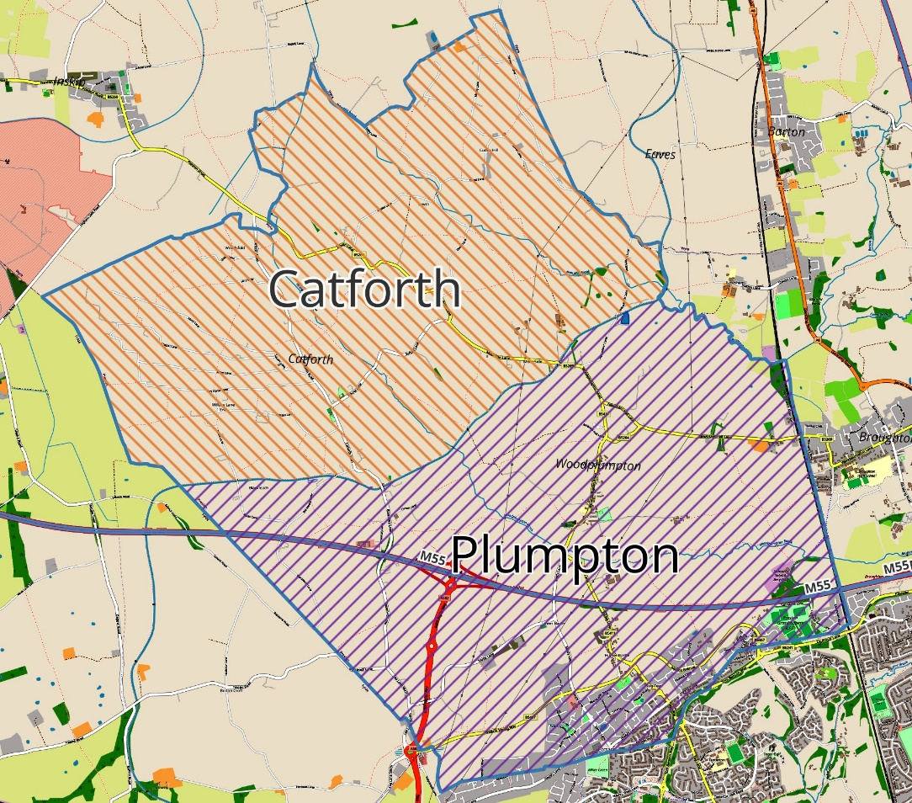
Figure 1 - Existing Warding
Current Ward | Electors | % of Ward | % of Total
Catforth Ward | 547 |  | 12.97%
Catforth | 309 | 56.49% | 7.33%
Woodplumpton | 232 | 42.41% | 5.50%
Preston | 6 | 1.10% | 0.14%
Plumpton Ward | 3669 |  | 87.03%
Cottam | 1879 | 51.21% | 44.57%
Higher Bartle | 677 | 18.45% | 16.06%
Lightfoot Green | 479 | 13.06% | 11.36%
Woodplumpton | 378 | 10.30% | 8.97%
Lower Bartle | 87 | 2.37% | 2.06%
Preston | 83 | 2.26% | 1.97%
Catforth | 55 | 1.50% | 1.30%
Bartle | 16 | 0.44% | 0.38%
Fulwood | 15 | 0.41% | 0.36%
Grand Total | 4216
Table 1 - Existing Parish Breakdown
Plumpton ward currently contains 87% of the parish residents. Catforth only 13%. If the number of councillors were decided today on the principle of proportionality, then Plumpton ward should have 7 councillors, Catforth should have 1.

Community Governance Review
A Community Governance Review (CGR) is a legal process whereby councils can create parish councils, review, and change parish electoral arrangements, boundaries, and in extreme cases abolish parishes.
Preston City Council (PCC) is not under a duty to carry out a CGR following the request from a parish council but it can choose to. However, if it receives a valid petition, then the council will be under a duty to carry out a review within 1 year. In our case, a petition must be signed by at least 10% of the electors in the parish to force PCC to undertake a review.
In conducting a CGR, PCC must look to see whether the community governance in the area reflects the identities and interests of the community and is effective and convenient. Additionally, if a review was undertaken, it must ascertain if a change would bring about improved community engagement, more cohesive communities, better local democracy, and more effective and convenient delivery of local services.
The petition must specify one or more proposed recommendations for review.
Some of the factors that define neighbourhoods are the geography of an area, the make-up of the local community, sense of identity, and whether people live in a rural, suburban, or urban area. The governance review would include consultation with residents.
WPC has the right to be consulted and would be able to affect the governance review’s points of reference by including them in the petition. However, once the governance review starts, it is down to the review body to decide what action should be taken.

Warding Group Outcome
WPC appointed a working group to assess representation across the parish. They were tasked with identifying the problems and putting together possible solutions if needed. The warding working group concluded there was a problem with representation in the parish and provided a number of solutions to WPC.

The Issue

Woodplumpton Parish Council was originally formed to represent a predominantly rural area. Today, the council consists of 8 elected councillors, with 5 representing the Plumpton ward and 3 representing Catforth.

Over the past decade, significant housebuilding in the southern part of the parish around Bartle has transformed the area. This increase in population has shifted the demographics and created a mismatch between current council representation and the areas they serve. Bartle has developed into a more urban area, while the wards of Woodplumpton and Catforth remain largely rural.

Currently, the council is composed of 7 councillors from rural areas and just 1 from the urban area around Bartle. While all councillors strive to serve the entire parish effectively, differing priorities between rural and urban areas highlight the importance of ensuring balanced representation. At future elections, this imbalance could result in Woodplumpton having no representation at all, which would significantly affect the community's interests and voice.

In response to these challenges, Woodplumpton Parish Council has considered recommendations from the working group and identified two viable solutions to address the representation imbalance. These options are outlined below.

Option 1 – Change the Warding within the Parish
After lengthy discussions it was agreed the most obvious boundary for the different wards would be the M55. North of the M55 is clearly made up of rural villages and south of it, new developments or land ear marked for further new developments, which have a more urban feel. As most of the signage in the area points to Bartle, Higher Bartle or Lower Bartle, it was decided Bartle would be the best name for any potential new ward. Despite a number of properties in the area taking the Cottam name, it was felt the name Cottam would potentially not be acceptable to many parishioners and could cause confusion with other parishes (namely Lea & Cottam).
Splitting the parish into 3 wards would provide the new developments with their own ward and their own councillors to represent them. This solution would also ensure Woodplumpton residents retain some representation.
Splitting the wards this way would also provide an opportunity to fix a few anomalies with the current split between Catforth and Woodplumpton.
The suggested changes can be seen in the example map in Figure 2 below.
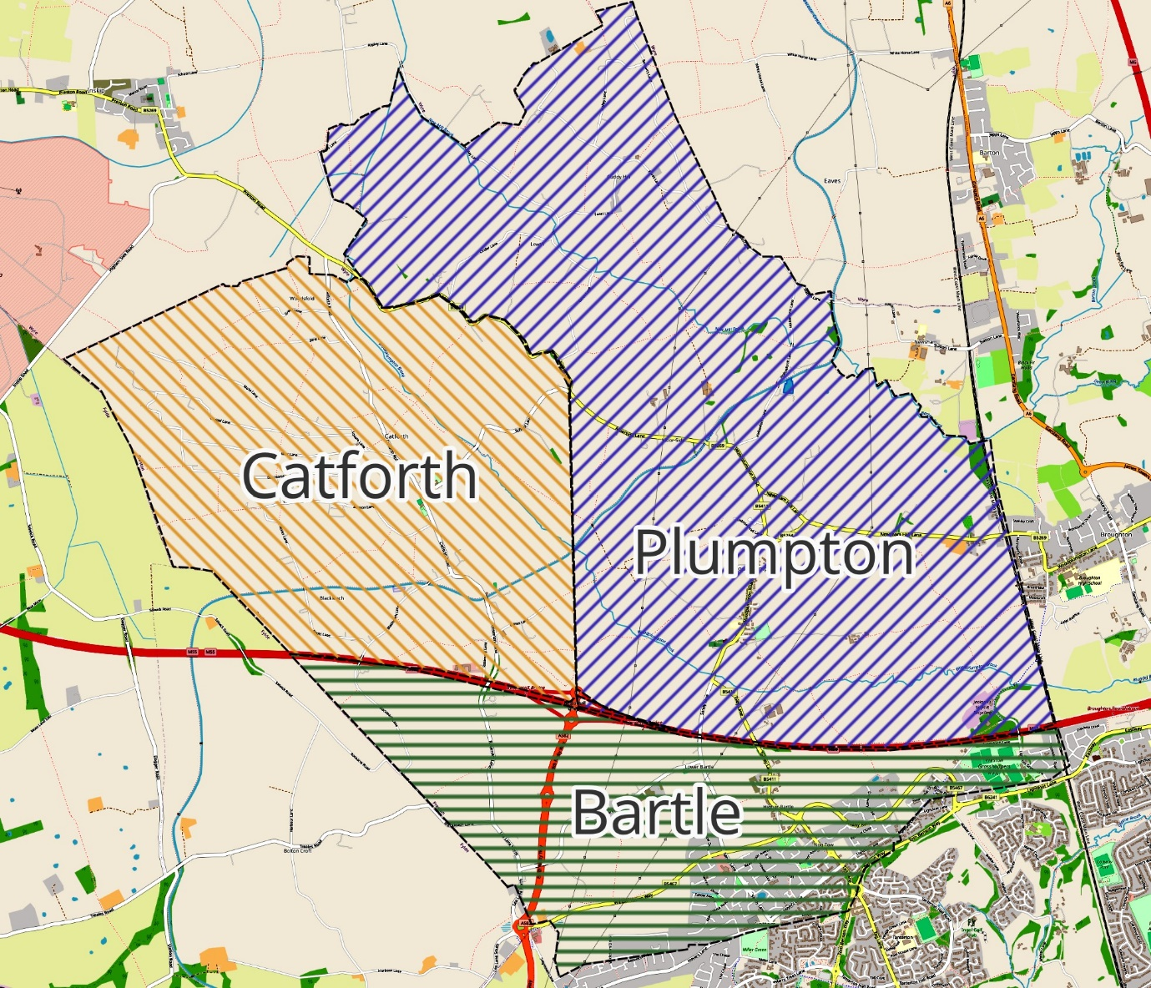
Figure 2 - 3 Ward solution

Potential New Ward | Electors | % of Total | Allocated Councillors
Bartle Ward | 3236 | 76.76% | 9
Catforth Ward | 370 | 8.78% | 1
Plumpton Ward | 610 | 14.47% | 2
Grand Total | 4216 |  | 12
Table 2 - 3 Ward Prediction
Table 2 shows how the warding would be broken down by population and how the split of councillors might be should there be 12 councillors. This number is merely a guide and will be discussed in much more detail should this be the desired approach for the parish. The numbers in the tables are also calculated using address data which is likely not to tie in exactly with the map data and so a more thorough analysis of each address would need to be undertaken before deciding final population and councillor breakdown.

The advantages of this approach:
- Provides Bartle ward with clear representation that better reflects their current and future neighbourhood, which would encourage political engagement.
- Ensures appropriate representation across all 3 areas of the parish based on the number of residents.
- Secures Woodplumpton’s representation for the future
- Woodplumpton and Catforth would still benefit from the ongoing Community Infrastructure Levy (CIL) that developers pay to the parish council. CIL provides the parish with considerable sums of money to improve the area.
The disadvantages of this approach:
- Catforth and Woodplumpton residents would likely lose overall control of the WPC.
- If residents from the new developments secure all the councillor seats in their ward, it could result in Woodplumpton and Catforth feeling overshadowed and underrepresented in overall WPC decisions.
- It will cost more to run due to added election costs.

Option 2 – Split the Parish entirely
The second option involves the Bartle area separating from the parish entirely. This would involve a boundary change which could also be considered under a CGR.
Should this happen, it would be sensible to reconfigure the allocated seats between Plumpton and Catforth wards due to the reduced size of Plumpton in the same way as option 1. A discussion could even be had over the need for 2 wards. Removing the warding could save the future PC a considerable sum in the long run.
Bartle would be able to either set up its own parish council, merge with another parish council or have no parish at all. Figure 3 below gives an example of how this could look if Bartle chose the new parish option.
The advantages of this approach:
- Clear demarcation of urban and rural interests, allowing each to focus on their specific needs and priorities.
- Allows the WPC to stand up for local rural issues more effectively as they would retain control.
- Bartle could start its own Parish Council or merge with another to give more weight to addressing issues such as estate maintenance and infrastructure projects.
- Bartle could join Lea & Cottam Parish Council (subject to their thoughts on the matter), who are likely to align better with the views of residents. More than 50% of “Bartle” residents actually have a Cottam address. Cottam is therefore likely to be the majority identity.
- A merged parish would also help fix boundary anomalies caused by the new developmens, neighbours currently in separate parishes, such as Bartle Meadows, could be reunited.

The disadvantages of this approach:
- Complex and potentially contentious process to separate the parish.
- Risk of economic and logistical challenges for the smaller rural parish.
- Catforth & Woodplumpton would no longer receive the substantial CIL money it currently receives from the new developments.

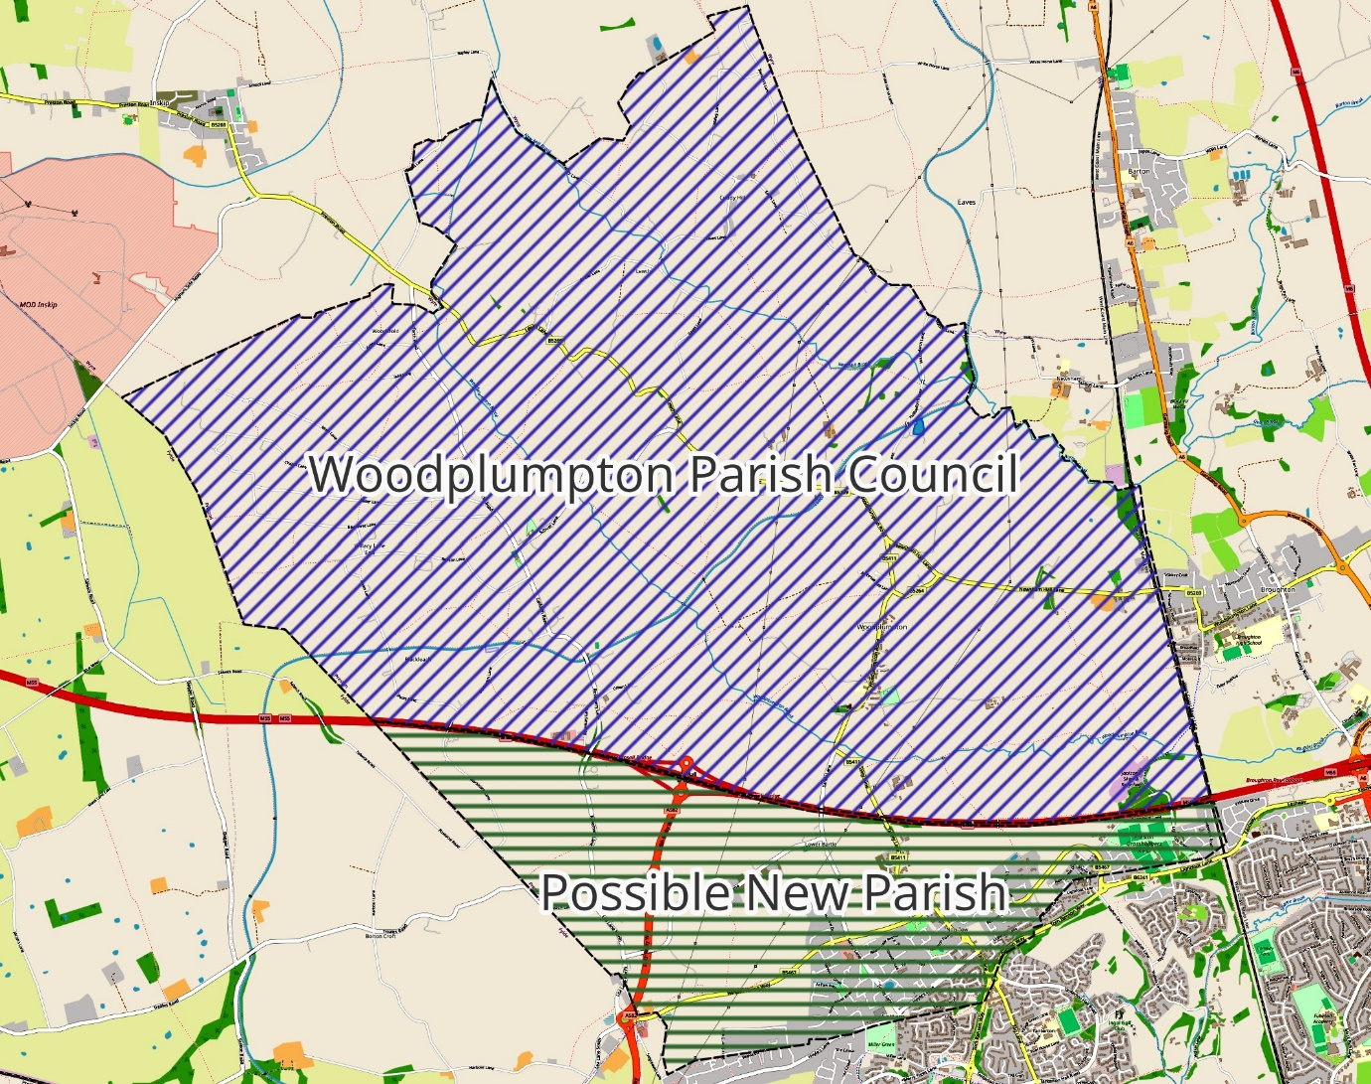
Figure 3 - Parish Split

